Institution Overview
- Name: K.S. School of Engineering & Management (KSSEM)
- Address: No.15, Mallasandra, Off. Kanakapura Road, Bengaluru-560109
- Contact: +91 9900710055
- Affiliations:
  - Affiliated to VTU, Belagavi
  - Approved by AICTE, New Delhi
  - Accredited by NAAC
- Group: Kammavari Sangham (R) 1952, K. S. Group of Institutions
- Admission: Open for the Academic Year 2026-2027
- Admission Contact: 9900710055

Department of Applied Science
- Role: Academic cornerstone for first-year engineering students.
- Subjects Offered: Physics, Chemistry, Mathematics, and Communication Skills.
- Objective: Provide foundational knowledge, analytical thinking, and problem-solving skills.
- Teaching Approach: Interactive teaching methods and collaborative learning environments.
- Facilities:
  - Well-equipped laboratories for hands-on experiments.
  - Encourages practical exposure and technical competence.
- Research & Innovation:
  - Promotes research and interdisciplinary collaboration.
  - Students encouraged to participate in mini-projects, workshops, seminars, and science fairs.

Recent Events and Activities
- Entrepreneurial Talk:
  - Speaker: Mrs. Raksha Karpoor, Founder of Paper Play
  - Event: On the occasion of World Entrepreneurs Day
  - Date: 29th August 2025
  - Time: 11:00 AM onwards
  - Venue: Architecture Seminar Hall
- Talk on "Exploring the Universe with Space Science Missions":
  - Speaker: Dr. Anuj Nandi, Senior Scientist, ISRO
  - Event: National Science Day 2025
  - Date: 2025 (exact date not specified)
  - Organized by: Department of Applied Science, in association with Civil Engineering and Electronics & Communication Engineering.
- Online Faculty Development Program:
  - Topic: "Nanomaterial and Energy Storage - Sustainable Future"
  - Duration: Six days
  - Dates: February 3rd to 8th, 2025
  - Organized by: Department of Physics, KSSEM, in association with K.S. Research and Innovation Foundation, KSGI
  - Sponsored by: AICTE - ATAL scheme

Department Profile
- Established: Since the inception of KSSEM in 2010
- Departments: Mathematics, Physics, Chemistry, Biology, and Humanities
- Faculty:
  - Total: 21 teaching faculties
  - Doctorates: 7
  - Supporting staff: 6
- Faculty Development:
  - Encourages participation in seminars, workshops, and conferences.
  - Motivates faculty to publish in reputed journals and submit project proposals to funding agencies.
  - Encourages Ph.D. enrollment.
- Infrastructure:
  - Engineering Mathematics, Chemistry, and Physics laboratories.
  - Equipped with major equipment to meet student needs.
- PROGRAM OUTCOMES
- PO1 : Engineering knowledge : Apply the knowledge of mathematics, science, engineering fundamentals, and an engineering specialization to the solution of complex engineering problems.
- PO2 : Problem analysis : Identify, formulate, research literature, and analyze complex engineering problems reaching substantiated conclusions using first principles of mathematics, natural sciences, and engineering sciences.
- PO3 : Design/development of solutions : Design solutions for complex engineering problems and design system components or processes that meet the specified needs with appropriate consideration for the public health and safety, and the cultural, societal, and environmental considerations.
- PO4 : Conduct investigations of complex problems : Use research-based knowledge and research methods including design of experiments, analysis and interpretation of data, and synthesis of the information to provide valid conclusions.
- PO5 : Modern tool usage : Create, select, and apply appropriate techniques, resources, and modern engineering and IT tools including prediction and modeling to complex engineering activities with an understanding of the limitations.
- PO6 : The engineer and society : Apply reasoning informed by the contextual knowledge to assess societal, health, safety, legal and cultural issues and the consequent responsibilities relevant to the professional engineering practice.
- PO7 : Environment and sustainability : Understand the impact of the professional engineering solutions in societal and environmental contexts, and demonstrate the knowledge of, and need for sustainable development.
- PO8 : Ethics : Apply ethical principles and commit to professional ethics and responsibilities and norms of the engineering practice.
- PO9 : Individual and team work : Function effectively as an individual, and as a member or leader in diverse teams, and in multidisciplinary settings.
- PO10 : Communication : Communicate effectively on complex engineering activities with the engineering community and with the society at large, such as, being able to comprehend and write effective reports and design documentation, make effective presentations, and give and receive clear instructions.
- PO11 : Project management and finance : Demonstrate knowledge understanding of the engineering and management principles and apply these to one's own work, as a member and leader in a team, to manage projects and in multidisciplinary environments.
- PO12 : Life-long learning : Recognize the need for, and have the preparation and ability to engage in independent and life-long learning in the broadest context of technological change.
- PROGRAM SPECIFIC OUTCOMES (PSO's)
- MATHEMATICS
- PSO1 : Ability to apply concept of Mathematics in engineering to design a system, a component or a process/system to address a real world challenges.
- PSO2 : Ability to develop effective communication, team work, entrepreneurial and computational skills.
- PHYSICS
- PSO1 : Ability to understand the basic principles, laws, theories and problem solving skills of Engineering Physics and their application in engineering and technology.
- PSO2 : Ability to apply the concepts of physics to design a process to address the real world challenges.
- CHEMISTRY
- PSO1 : Ability to apply concept of Chemistry to design a system, to address a real world challenges.
- PSO2 : Ability to develop effective communication, team work and computational skills.
Mathematics
The Department of mathematics came into existence since the inception of KSSEM in 2010. The mathematics department at KSSEM allows budding engineering students to explore their world and discover new things in the field of technology. It is also an active department, containing various research activities with hands-on labs and experiments and many more. This makes the mathematics department well-suited to excel the future of young budding engineers. The motto of the Department is to provide high quality education to students with the assistance of well-qualified, dedicated and highly motivated faculty members. Our faculty's research expertise includes all frontier areas in Mathematics. We impart the best teaching methodologies which prepare competent professionals able to independently apply knowledge to become a successful engineer.
Head Of The Department Desk
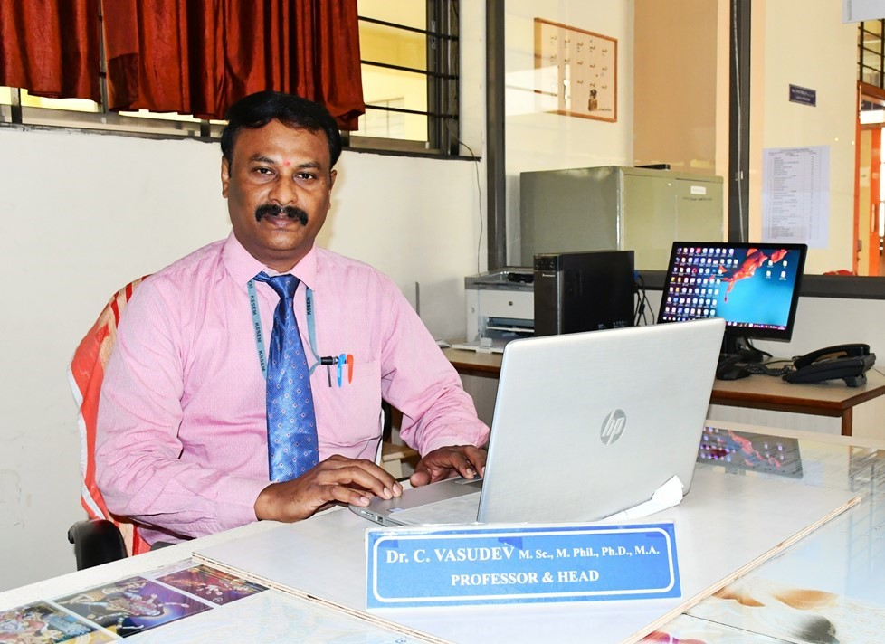
Dr. C Vasudev
Professor & Head
M. Sc., M. Phil, Ph. D, M.A. (Tel.Litt), MIAENG, FMIRED
The Department of Mathematics grew with the progress of the institution. Presently it consists of 09 faculties out of which 3 are doctorates. The department encourages the faculty to attend seminars, workshops & conferences. The department motivates the faculty to publish papers in reputed journals, submit project proposal to funding agencies & to enrol for PhD program.
The department has well qualified, experienced and dedicated faculty, who are blend of knowledge and experience. The department provides safe, positive & intellectual learning environment. The aim of the faculties to provide quality education to the student community by utilizing modern teaching aids. The strong basic foundation laid by the department helps the students to apply knowledge & to become a successful engineer.
Vision
- To build a strong mathematical foundation that empowers students to pursue engineering and scientific education with clarity, confidence, and competence.
Mission
The Department of Mathematics is dedicated to:
- Cultivating analytical thinking and problem-solving skills through rigorous mathematical training.
- Promoting an academic environment that embraces current advancements in science and technology.
- Enhancing student's communication abilities while instilling core human values and ethical responsibility.
Highlights of department
- Department has highly dedicated & experienced faculty members backed up with strong research & teaching skills.
- State of art infrastructure & laboratory facilities.
- R&D Center of mathematics Department has awesome facilities with top class research facilities helping students & faculties to develop their research abilities.
- Excellent infrastructure: building, space, class-rooms, seating arrangements, etc.
- Excellent teaching and learning environment with modern technology with online videos /Presentations.
- Unique department library facility for quick & ready reference.
- Involving the students in various extra-curricular activities like sports, cultural programs etc.
- Dedicated mentors with Effective mentoring system.
Welcome to Department of Chemistry
The Department of Chemistry was established within the Applied Science Department since the inception of KSSEM in 2010. The department has focused on providing a strong foundation in chemistry as part of a broader scientific curriculum.
Head Of The Department Desk
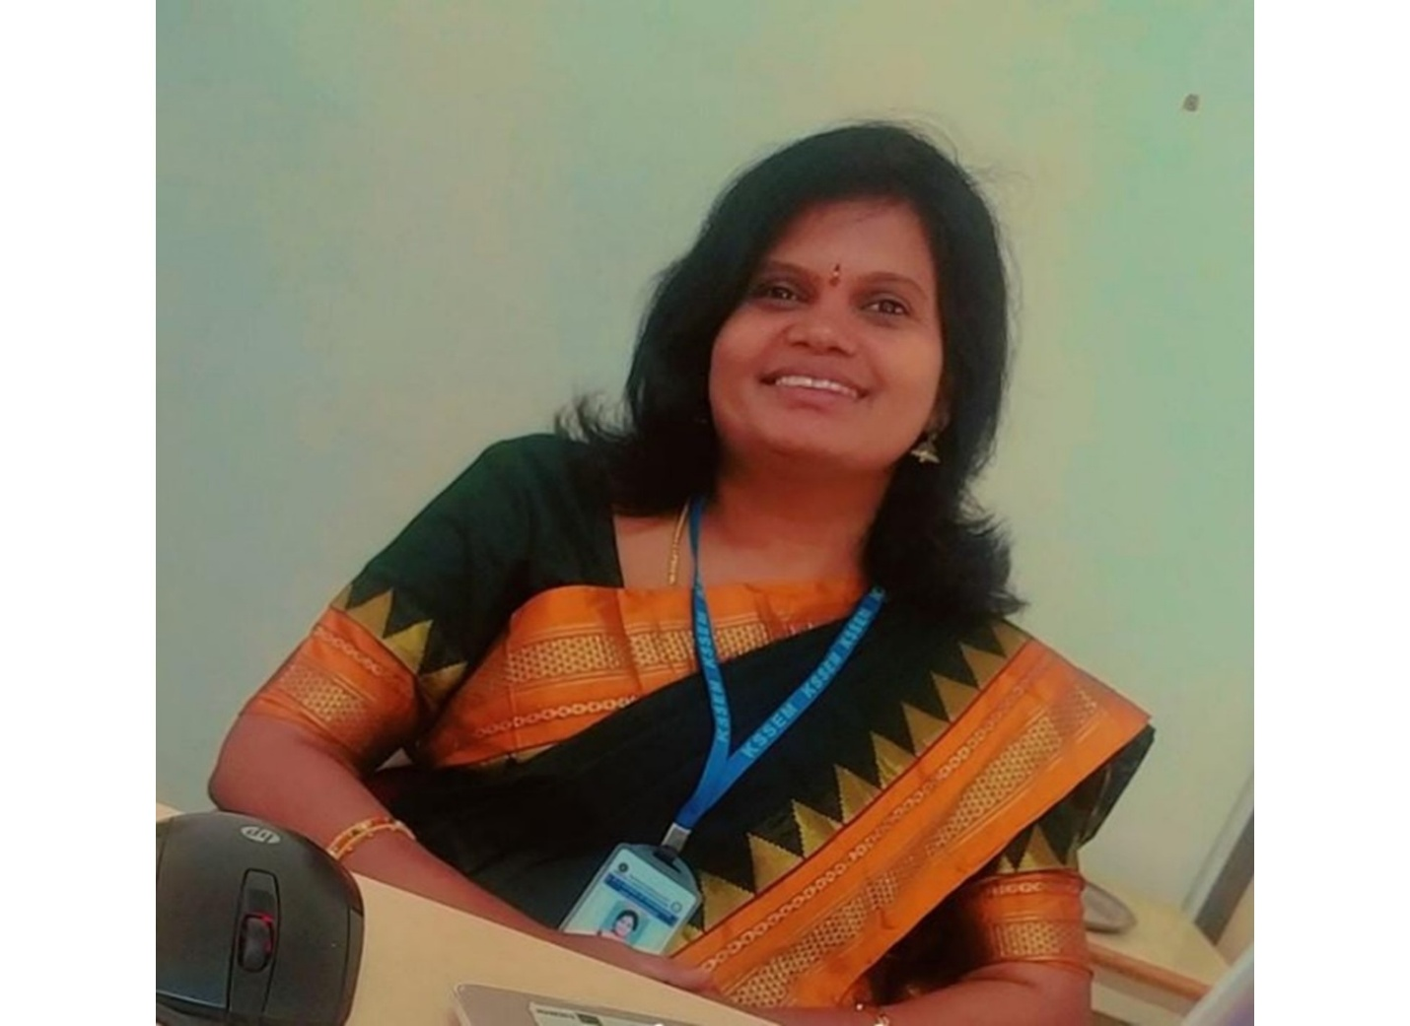
Dr. Swarna S
Head, Dept of Chemistry
The mission of the Department of Chemistry is to equip students with the knowledge and practical skills essential for thriving in both academia and industry. Currently, the department consists of 5 faculty members, out which 3 are doctorates. The Department of Chemistry offers high-quality education, supported by a team of well-qualified, dedicated, and motivated faculty members. These faculty members possess research expertise in various cutting-edge areas of chemistry, ensuring that students receive a comprehensive education grounded in both theory and practical application.
The department is equipped with modern teaching methodologies that prepare students to independently apply their knowledge and become successful professionals. The well-established Engineering Chemistry laboratory is fully equipped with state-of-the-art equipment, catering to the academic and research needs of students.
The department actively encourages faculty to participate in seminars, workshops, and conferences, and motivates them to publish their work in reputed journals, submit project proposals to funding agencies, and pursue Ph.D. programs.
The Department of Chemistry offers a positive, intellectually stimulating learning environment. The goal is to provide students with the skills and knowledge necessary to thrive in both academic and industrial settings, contributing to advancements in sciences and engineering.
Vision
- To provide a strong foundation in Chemistry and related subjects, enabling students to excel in the field of engineering while fostering a deep understanding of core scientific principles.
Mission
The Department of Chemistry aims to:
- Cultivate analytical and problem-solving skills across a broad range of Chemistry
- Ensure that students stay updated with the latest advancements in scientific research and applications.
- Develop strong communication skills and imbibe human values to prepare well-rounded professionals.
Highlights of the Department
- The department features a team of highly committed and experienced faculty members who excel in both research and teaching.
- Equipped with state-of-the-art infrastructure and laboratory facilities.
- The R&D centre offers exceptional resources and top-tier research facilities that support both students and faculty in advancing their research skills.
- Outstanding infrastructure, including spacious buildings, well-designed classrooms, and comfortable seating arrangements.
- A modern teaching and learning environment, enhanced by technology, including online videos and presentations.
- A dedicated mentoring system with effective mentors providing continuous guidance.
Welcome to Department of Physics
The Department of Physics at KSSEM was established in 2010. The department strives to be a dynamic, inclusive, and competitive centre of excellence in physics teaching, learning, and research in order to meet the technical needs of engineering students. The faculty members in the department are highly skilled, knowledgeable, and passionate. Faculty in the department teaches Applied Physics to first-year B E students.
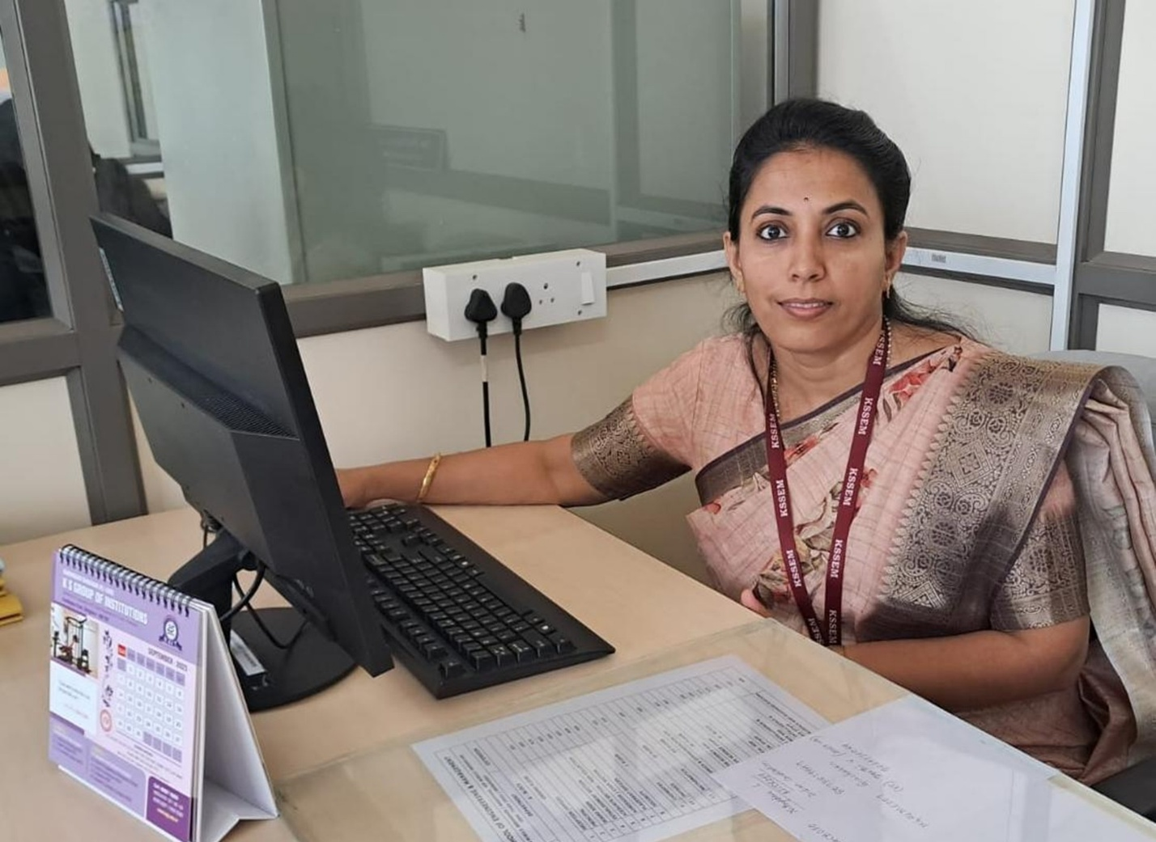
Dr. Pavithra J
Assistant Professor & HOD
M.Sc., B.Ed., Ph.D
The physics department goal is to impart strong mathematical and problem-solving abilities, a thorough comprehension of physical principles, and a broad understanding of experiments that can spark students' interest and passion to learn physics in connection to professional courses.
The department owns an ergonomically designed and well-equipped Applied Physics Laboratory with modern types of equipment and a spacious darkroom for optics experiments. The department ensures the good academic progress of the students by adopting the best practices of the teaching and learning process.
The department actively supports faculty members to participate in conferences, workshops, seminars and publish papers in national / international conferences/journals. It also encourages them to submit project proposals to funding agencies and pursue Ph.D. programs.
Vision
- To provide fundamental knowledge in physics that empowers engineering students with the skills to solve real-world problems and contribute to technological and societal advancement.
Mission
Department of Physics shall,
- Impart a strong conceptual and experimental foundation in Physics relevant to engineering disciplines.
- Encourage interdisciplinary learning by connecting Physics with engineering and emerging technologies.
Highlights of Department
- Well trained, competent and highly motivated faculty members.
- State of art infrastructure & laboratory facilities.
- Excellent infrastructure, including spacious buildings, well-designed classrooms, and comfortable seating arrangements.
- Adequate teaching aids like black/white boards, LCD projectors, etc.
- Rich tradition in research and teaching.
- Dedicated mentoring system with capable mentors providing continuous guidance.
- Mathematics Faculty
- 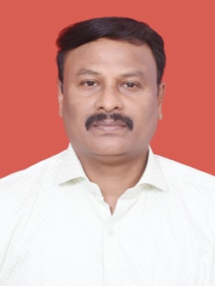
- Dr. C Vasudev
- Professor & Head
- M. Sc., M. Phil, Ph. D, M.A. (Tel.Litt), MIAENG, FMIRED
- 
- Dr. Lakshmi B
- Associate Professor
- M.Sc., Ph.D.
- 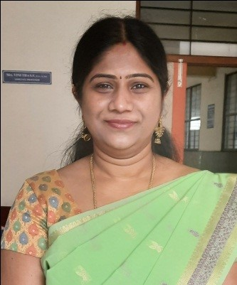
- Dr.Vinutha S V
- Associate Professor
- M. Sc, M. Phil, Ph.D
- 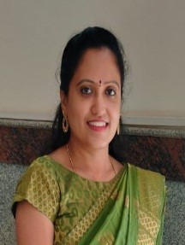
- Nagarathna T K
- Assistant Professor
- M.Sc., B.Ed.,(Ph.D)
- 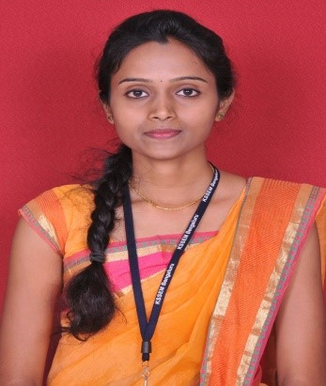
- Divya R
- Assistant Professor
- M.Sc., B.Ed.,(Ph.D)
- 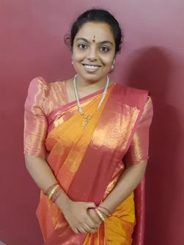
- Pannaga P I
- Assistant Professor
- M.Sc
- 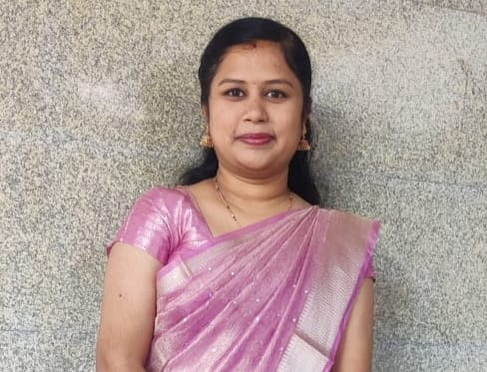
- Mrs. Suman
- Assistant Professor
- M.Sc
- Physics Faculty
- 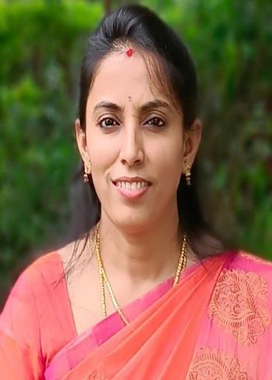
- Dr. Pavithra J
- Associate Professor and HoD
- M.Sc, B.Ed, KSET, Ph..D
- 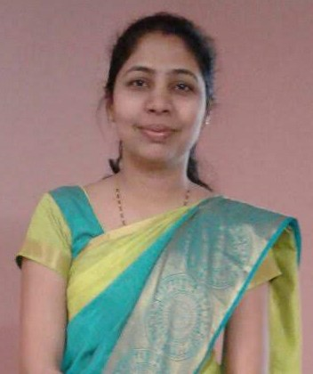
- Dr. Vaishali R Bote
- Assistant Professor
- M.Sc. Ph.D.
- 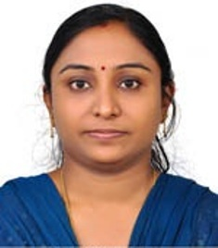
- Dr. Nisha PG
- Assistant Professor
- M Tech, PhD
- 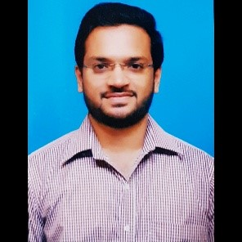
- Mr. Keerthi A
- Assistant Professor
- M.Sc.
- Chemistry Faculty
- 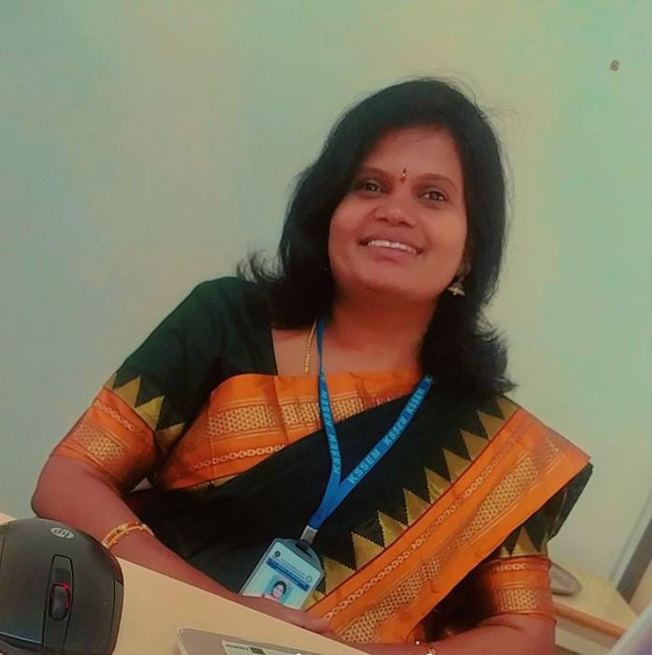
- Dr. Swarna S
- Associate Professor and HoD
- M.Sc., Ph.D.
- 
- Dr.Radha H.R
- Associate Professor
- M.Sc., Ph.D
- 
- Dr. Anitha R
- Assistant Professor
- M.Sc., Ph.D.,
- 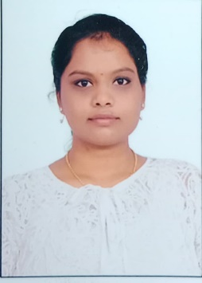
- Mrs. Ashvini E
- Assistant Professor
- M.Sc , Biotechnology
- 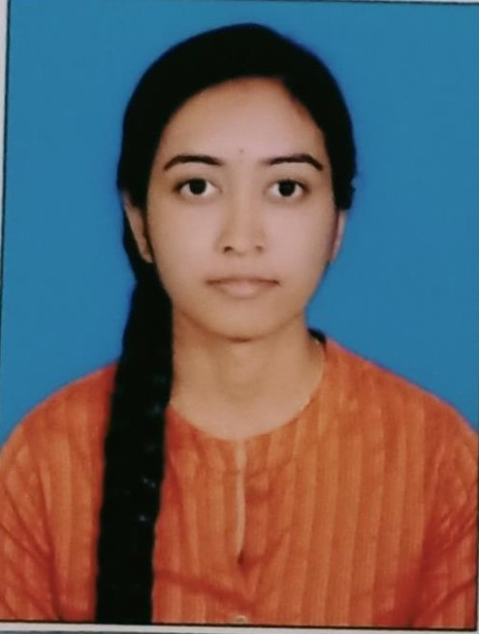
- PALLAVI B N
- Assistant Professor
- M.Sc (Organic Chemistry)
- Humanities Faculty
- 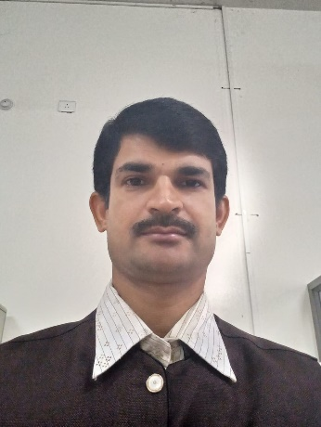
- Thrimurthy R
- Assistant Professor
- M.A.(Kannada) M.Ed., NET
- 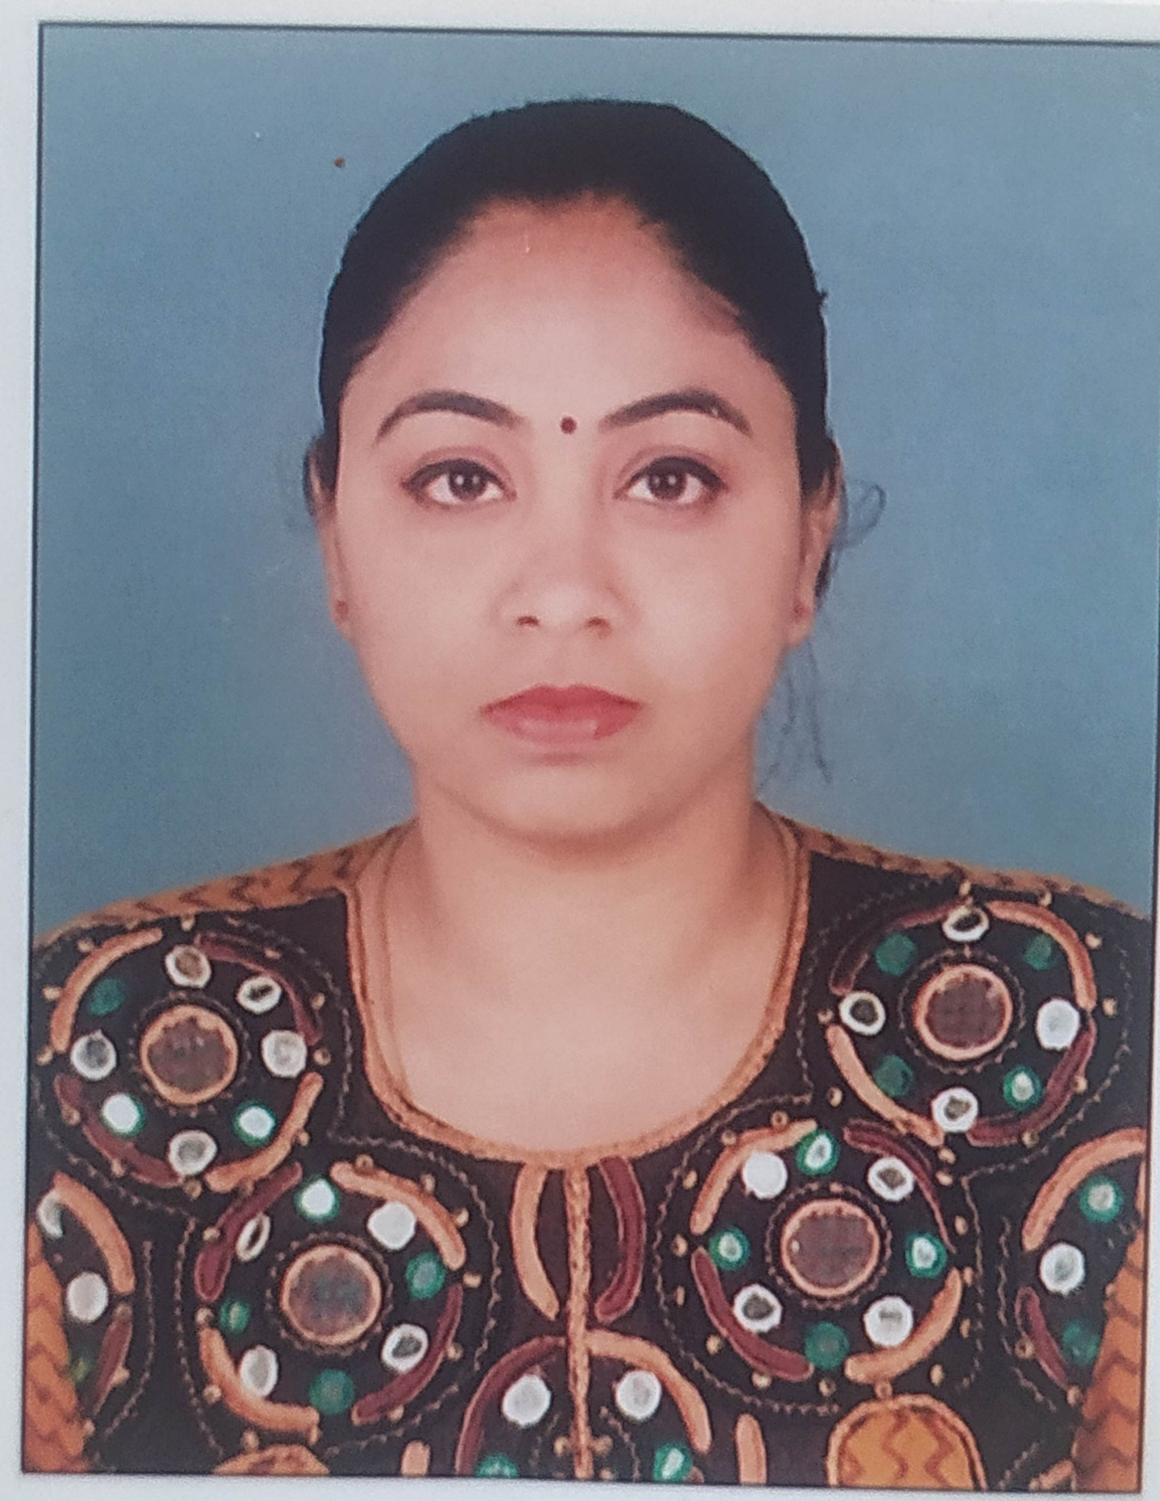
- Ashvini E
- Assistant Professor
- BA (Law) ., LLb., LLM.,MA M Phil Political Science., PG HRM
- 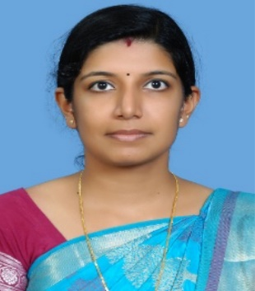
- LEKSHMY PRABHA.S
- Assistant Professor
- M.A, M.Ed.
- Supporting Staff Faculty
- 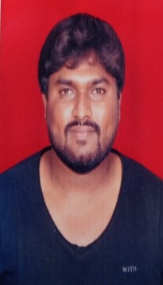
- AVINASH R
- Instructor
- B.COM
- 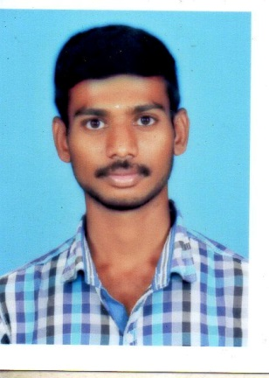
- Nagendra
- Instructor
- B.Sc
- 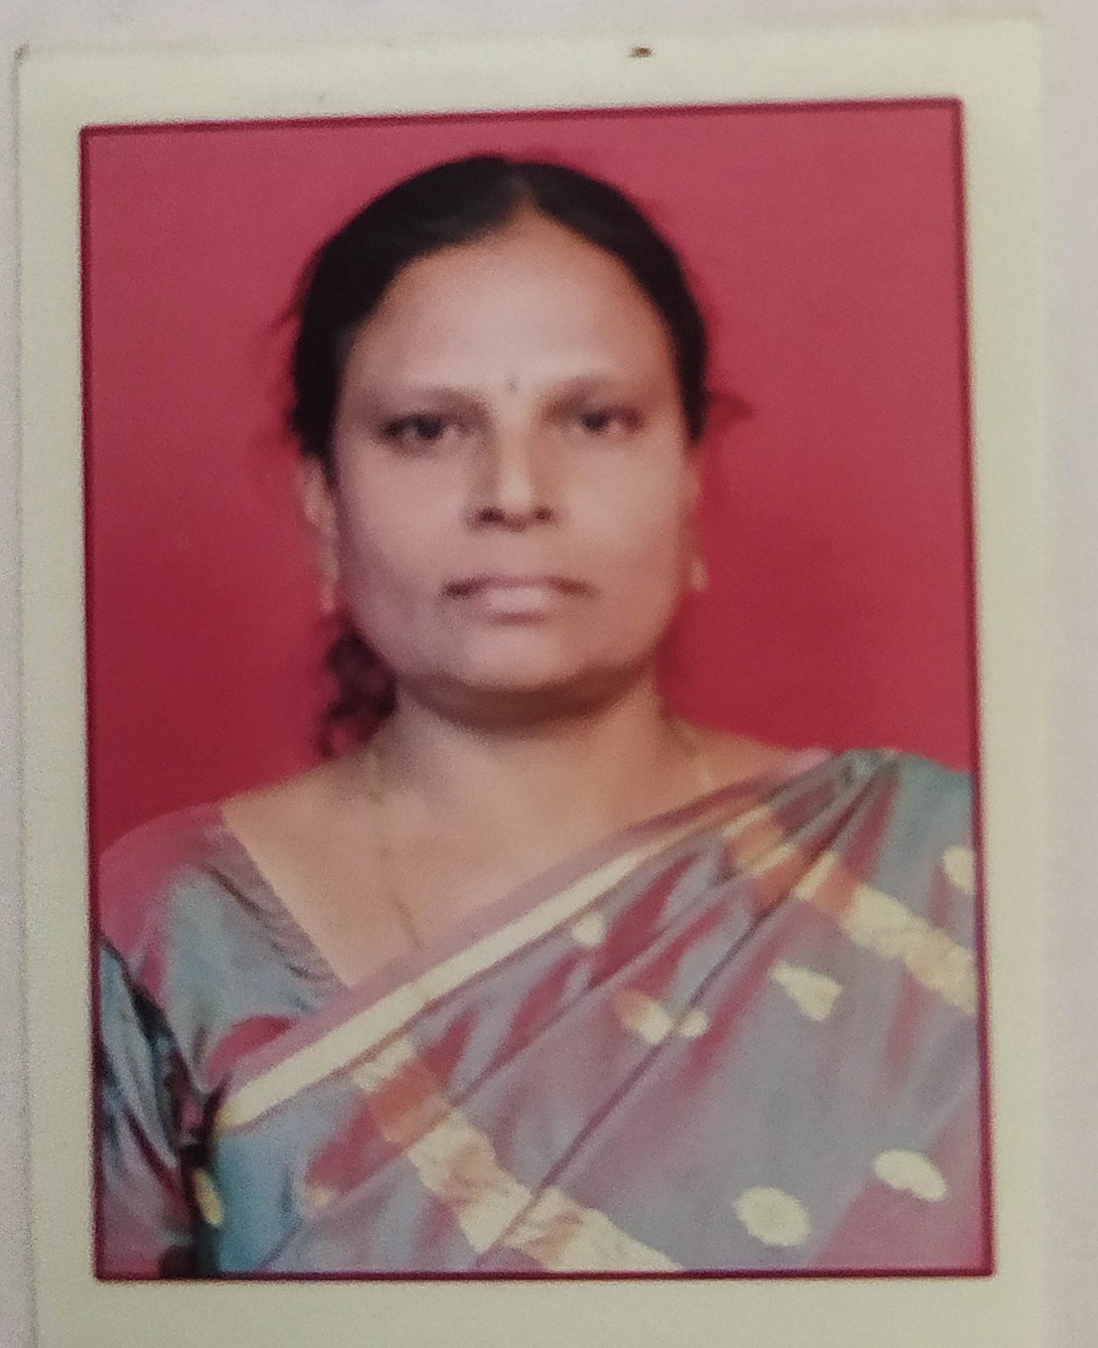
- UMA
- Attender
- SSLC
- 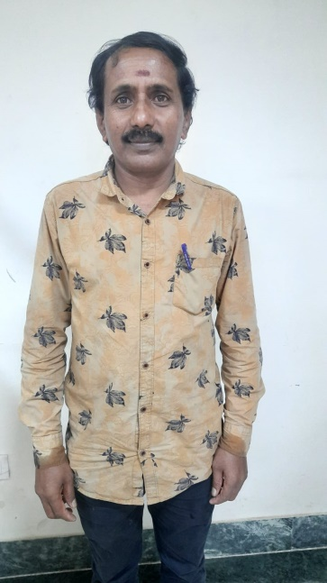
- Keshava
- Attender
- S.S.L.C
- 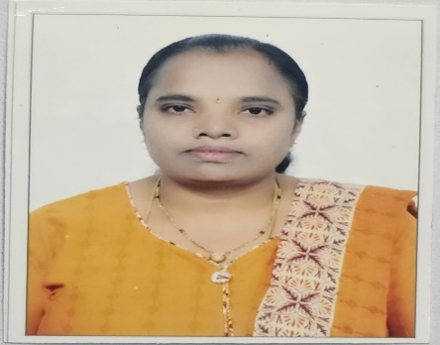
- Bhuvaneswari K
- Office Assistant
- M.Sc Biotech
- MOUs Signed
A Memorandum of Understanding (MoU) is a formal agreement between two or more parties. Companies and organizations can use MoUs to establish official partnerships. The MoU intends to jointly work on projects required for industries and research needs. Faculty with good industrial experience and promising students, jointly agree to exchange their expertise for mutual benefit and growth.
image
- VTU-UHV Cell Monthly Lecture Series-X on UNIVERSAL HUMAN VALUES
- "VTU-UHV Cell Monthly Lecture Series-X on UNIVERSAL HUMAN VALUES Organized by Department of Physics on 30-10-2025 Academic Year: 2025-26"
- 2025-10-30

- INDUCTION PROGRAM-PHYSICS CYCLE
- " INDUCTION PROGRAM FOR THE FIRST YEAR B.E. STUDENTS(2025-26)"
- 2025-09-08

- INDUCTION PROGRAM-CHEMISTRY CYCLE(2025-26)
- "INDUCTION PROGRAM FOR THE FIRST YEAR B.E. STUDENTS FROM 08/09/2025 TO 13/09/2025"
- 2025-09-08

- 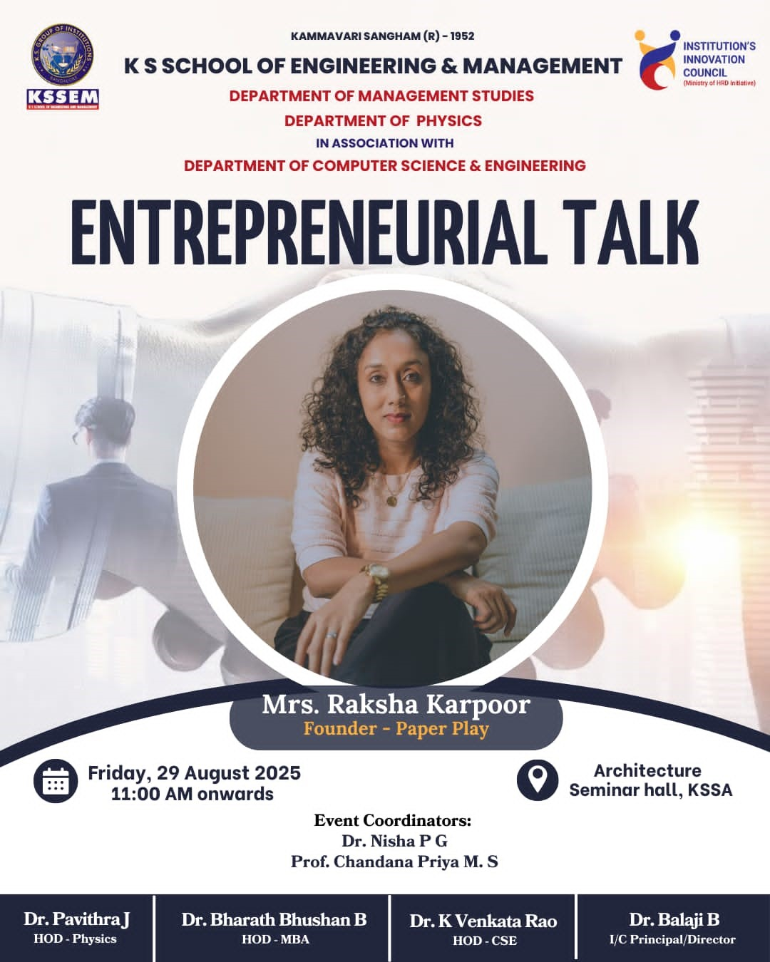
- Entrepreneurial Talk by Mrs. Raksha Karpoor, Founder- Paper Play, on the occasion of World's Entrepreneurs Day celebration
- "The Department of Physics and the Department of Management Studies, in association with the Department of Computer Science and Engineering are organizing an Entrepreneurial Talk by Mrs. Raksha Karpoor, Founder- Paper Play, on the occasion of World Entrepreneurs Day celebration on 29th August 2025 at 11:00 AM onwards in Architecture Seminar Hall. "
- 2025-08-29

- 5th aniversary of National Education Policy(NEP)-2020
- "Department of Chemistry in associated with Department of Civil Engineering is Organizing an Expert talk on Significance of NEP by Dr. Bhaskar S, Professor, KCT, on 29/07/2025"
- 2025-07-29

- WORLD INTELLECTUAL PROPERTY
- "WORLD INTELLECTUAL PROPERTY"
- 2025-06-10

- NATIONAL SCIENCE DAY
- "HELD ON 24th FEBRUARY 2025 ORGANIZED BY DEPARTMENT OF APPLIED SCIENCE IN ASSOCIATION WITH DEPARTMENT OF CIVIL ENGINEERING AND DEPARTMENT OF ELECTRONICS & COMMUNICATION ENGINEERING K.S. SCHOOL OF ENGINEERING AND MANAGEMENT"
- 2025-02-24

- 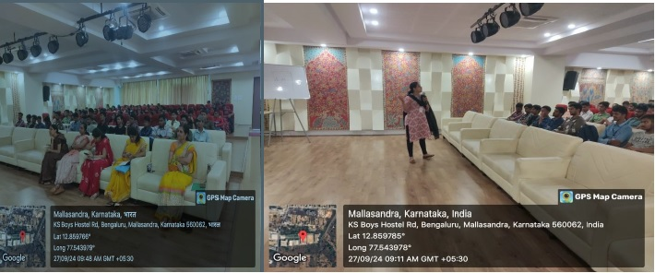
- Induction program (Chemistry Cycle)
- "Induction Program for first year Students Chemistry Cycle (2024-25)"
- 2024-09-18

- 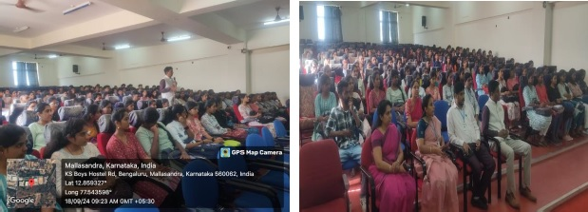
- Induction Prograam(Physics Cycle)
- "Induction Program for First year Students_Physics cycle(2024-25)"
- 2024-09-18

- 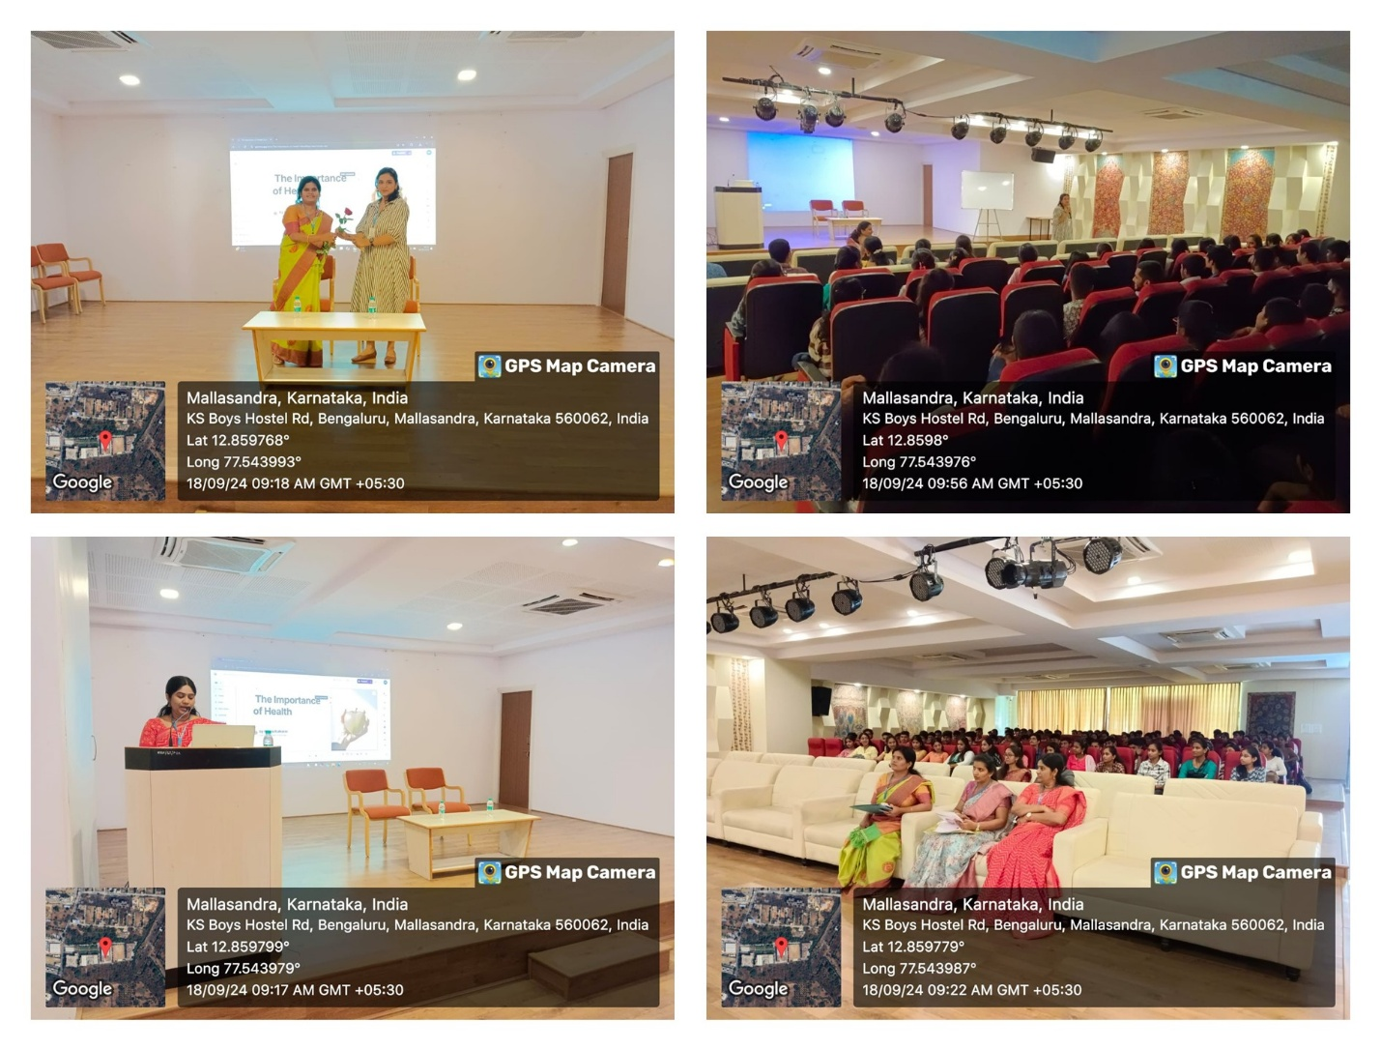
- Induction Program - Session 1 on Importance of Physical Health by Dr. Kokila Kulkarni
- "A session on the Importance of Physical Health was conducted on 18/09/2024 with Dr. Kokila Kulkarni, a renowned health expert, as the speaker. Dr. Kulkarni emphasized the crucial role physical well-being plays in leading a balanced and fulfilling life. She highlighted the benefits of regular exercise, a nutritious diet, and proper sleep, explaining how they directly impact both mental and emotional health. The session also covered practical tips for incorporating fitness into daily routines and managing stress through physical activity. Dr. Kulkarni engaged the audience with real-life examples, interactive discussions, and Q&A, making the session highly informative and impactful. Overall, the event successfully raised awareness about the need for prioritizing physical health in our everyday lives, encouraging students and staff to adopt healthier lifestyles. "
- 2024-09-18

- Motivational Talk
- " Motivational Talk On " Engineering: The Path Forward" The Department of Basic Science, KSSEM has organized a motivational talk on "Engineering: The Path Forward? on 18 March 2021. The talk was held in Civil Seminar Hall for I semester students. "
- 2021-03-18

- INDUCTION PROGRAM(2023-24)
- "Induction program was organized for first year students(2023-24)"
- 2023-04-09

- NATIONAL SCIENCE DAY
- "HELD ON 24th FEBRUARY 2025 ORGANIZED BY DEPARTMENT OF APPLIED SCIENCE IN ASSOCIATION WITH DEPARTMENT OF CIVIL ENGINEERING AND DEPARTMENT OF ELECTRONICS & COMMUNICATION ENGINEERING K.S. SCHOOL OF ENGINEERING AND MANAGEMENT"
- 2025-02-24

- ""

- ""

- KATALYST Program
- "Katalyst Program was organised for first year BE 2023-2024 batch girl students at KSSEM, on 09-09-2023."
- 2023-09-0
- s

